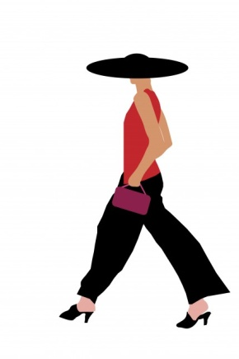 

YOUR STYLE QUESTIONAIRE

TELL US ABOUT YOURSELF

|  |
| --- |
| **Name:** |
| **Email Address­­­­­­­­­:** |
| **Phone number:** |
| **Address:** |
| **City: State: Zip Code:** |
|  |
| **Occupation:** |

What’s the dress code at your workplace? 

Age 

Gender

Male

Female

Have you ever worked with a Personal Stylist before? 

If yes, how was your experience? 

What has inspired you to contact us? What’s happening in your life?



Why did you choose **L STYLE ME** over other stylists?



What are your style and wardrobe goals? What are you hoping to achieve?



Hair Color 

Eye Color 

Your Complexion 

Your Best Assets (Select all that apply)

Arms

Shoulders

Chest

Stomach

Back

Butt

Hips

Legs

Your Concerns & Problem Areas (Select all that apply)

Arms

Shoulder

Chest

Stomach

Back

Butt

Hips

Legs

YOUR SIZING INFO

Waist: 

Hips: 

Height: 

Weight: 

Your typical sizes (What sizes do you normally wear?)

  
What dates might work for you?





What kind of budget are you looking at for your total shopping excursion?



How did you find **L STYLE ME?**







What should we know about your style, fashion discomforts, & body discomforts (i.e. don't want to show upper arms, etc...)



Please name 3 celebrities whose styles you admire



Hobbies/Interests. What is your lifestyle like?



What are your favorite stores/designers? (If you have any) Where do you typically shop?



HOW TRUE ARE THE FOLLOWING STATMENTS FOR YOU?

I enjoy shopping.

Strongly Disagree

Disagree

Neutral

Agree

Strongly Agree

I have a hard time finding pieces I like.

Strongly Disagree

Disagree

Neutral

Agree

Strongly Agree

I have a hard time finding pieces that fit me well.

Strongly Disagree

Disagree

Neutral

Agree

Strongly Agree

I have a hard time finding pieces that work well with my existing pieces.

Strongly Disagree

Disagree

Neutral

Agree

Strongly Agree

I have a hard time putting nice outfits together.

Strongly Disagree

Disagree

Neutral

Agree

Strongly Agree

I feel like my wardrobe is outdated and old.

Strongly Disagree

Disagree

Neutral

Agree

Strongly Agree

I don't have time (or patience) to shop.

Strongly Disagree

Disagree

Neutral

Agree

Strongly Agree

What have you done so far to improve your personal style?



Is there anything else you'd like to tell us about yourself? Do you have any questions for us?



Your Location *

Tell us where you want your personal styling services.



Promo code if applicable

